Comprehensive Analysis of Indian State Assembly Elections (2009-2021)

1. Project Overview

This report presents a comprehensive exploratory data analysis (EDA) of the Indian State Assembly Elections dataset, covering the period from 2009 to 2021. The objective of this project is to dissect various facets of state-level electoral processes, from candidate demographics and party participation to voter behavior and political outcomes. By employing a multi-faceted analytical approach—including univariate, bivariate, multivariate, and geospatial analysis—this report aims to uncover key trends, underlying patterns, and actionable insights that characterize India's vibrant and complex democratic landscape at the state level. The analysis leverages a rich dataset containing candidate-level information, which has been meticulously cleaned, prepared, and enriched with district-level mapping to ensure accuracy and depth

2. Report Structure
This document follows a systematic analytical workflow to extract meaningful insights from the dataset:
1. Data Exploration & Diagnostics
2. Data Cleaning Process
3. Descriptive & Statistical Analysis
4. Univariate Analysis
5. Bivariate & Multivariate Insights
6. Key Findings
7. Summary & Conclusion

3. Data Exploration & Diagnostics

The dataset comprises over 122,000 candidate-level records and 24 features, including detailed information on the election year, state, constituency, party affiliation, candidate demographics, and electoral outcomes. The detailed Preliminary exploration revealed that while most features were complete, the age column contained a significant number of missing values that required imputation. The dataset also included non-candidate entries such as 'NOTA' (None of the Above) and records for candidates below the legal contesting age, which needed to be filtered out. These initial diagnostics confirmed the necessity of a robust data cleaning and preparation phase to ensure the consistency and validity of the final analysis. To ensure that the granularity of the dataset remains to the district-level, a dataset which had assembly constituencies mapped to their respective districts was integrated in the original dataset.

4. Data Cleaning Process
Column names in the supplementary mapping data were standardized for consistency (e.g., ST_NAME to state_name). A review of the primary dataset identified and handled several types of invalid records. All entries corresponding to 'NOTA' (None of the Above) were separated from the main dataset to ensure analysis focused solely on human candidates. Furthermore, rows for candidates under the legal contesting age of 25 were removed.
The age column, which had a notable number of missing values, was imputed using a grouped median strategy based on the candidate's party, sex, and state to ensure the imputed values were contextually appropriate and preserved the data's integrity. To enrich the dataset, a district column was added by mapping constituency names to a supplementary file; a fuzzy string-matching algorithm was employed to handle spelling variations and ensure a mapping accuracy of over 99%.
5. Descriptive & Statistical Analysis
Numerical summaries of the electoral data revealed that key performance metrics are highly varied and often skewed. The margin_percentage for winning candidates is strongly right-skewed, with a range from nearly zero to over 75%. This indicates that while many electoral contests are closely fought, a significant number of landslide victories act as high-end outliers. Similarly, vote_share_percentage shows a wide distribution, skewed toward low values, confirming that a majority of candidates secure only a small fraction of the total votes. In contrast, features like candidate age and constituency turnout_percentage are nearly symmetrical

6. Summary of Analysis & Key Insights

6.1 Univariate Analysis: Profiling the Electoral Landscape

Candidate Demographics: The age distribution of candidates is nearly symmetrical, with a mean and median age of approximately 47, indicating that political contestation is dominated by experienced individuals. A significant insight is the profound gender disparity, with males constituting over 93% of all candidates

Party Participation: While Independent candidates are the largest single group by participation, major national parties like the BJP, INC, and BSP field the highest number of candidates among registered parties.

Electoral Health: Voter turnout is generally high and normally distributed, with a median turnout rate of over 75% across constituencies. The distribution of winning margins is right-skewed, revealing that while many races are competitive, a significant number of seats are won by large, landslide margins.

6.2 Bivariate & Multivariate Analysis: Uncovering Relationships

Party Performance & Strike Rate: The analysis of win percentages (strike rate) reveals a crucial distinction between participation and success. While national parties contest the most seats, dominant regional parties like AITC and DMK exhibit a significantly higher strike rate, converting a larger percentage of their contests into victories. Among the top 5 most active national parties, the BJP demonstrates the highest strike rate, both in general and reserved (SC/ST) constituencies.

State-Level Dynamics: The seat retention analysis highlights the fluid nature of state politics. In every 5-year election cycle, dominant parties both "retain" a core set of seats and "grab" a substantial number from competitors, indicating a highly dynamic and competitive environment.

Complex Interactions: Multivariate analysis showed no strong linear correlation between a candidate's age and their vote share across different genders and parties. Furthermore, the relationship between voter turnout, the number of candidates, and the winning margin is complex, suggesting that factors beyond simple vote-splitting determine the closeness of a race.

6.3 Geospatial Analysis: Visualizing Political Strongholds

Geographic Concentration of Wins: The choropleth map provides a clear visualization of political influence. The analysis confirms that the BJP's electoral success is geographically concentrated in the states of the Hindi heartland (Northern, Western, and Central India), where it has secured the highest number of assembly seats between 2009 and 2021. This visual evidence powerfully corroborates statistical findings about party performance.
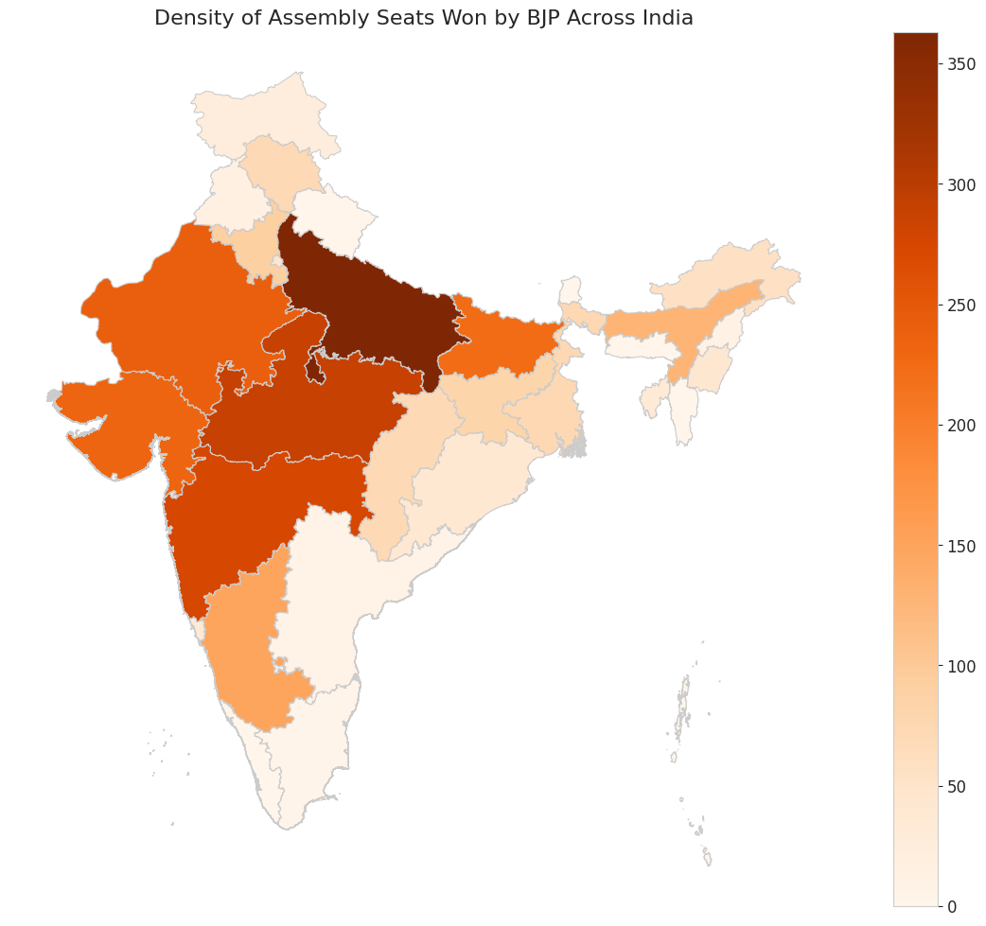

7. Key Findings:

The comprehensive analysis of the State Assembly Elections dataset yielded several critical findings that characterize the Indian electoral landscape between 2009 and 2021.

Profound Gender Disparity in Political Contestation: The most significant demographic finding is the severe underrepresentation of women in electoral politics. Over 93% of all candidates were male, highlighting a persistent and substantial gender gap in political participation.

Dominance of Experienced Candidates: The age distribution of candidates is remarkably consistent, with a median age of approximately 47. This indicates that electoral politics is predominantly a field for experienced individuals, with similar age profiles observed across all major national parties.

High Participation but Low Success for Independents: Independent candidates constitute the largest single group by participation. However, their electoral success is minimal, with a win rate of less than 1%. The vast majority secure only a small fraction of the vote, underscoring the critical role of party machinery in winning elections.

Regional Parties Exhibit Superior Electoral Efficiency: While national parties like the BJP and INC field the most candidates, dominant regional parties such as AITC and DMK demonstrate a significantly higher "strike rate" (win percentage). This highlights their concentrated influence and efficiency in converting electoral contests into victories within their respective states.

Geospatial Concentration of Political Power: The geospatial analysis visually confirms the BJP's electoral strongholds. The party's success in assembly elections is heavily concentrated in the states of the Hindi heartland (Northern, Western, and Central India), providing a clear geographical map of its political influence.

Dynamic and Competitive State-Level Politics: The seat retention analysis reveals a fluid political environment. In each 5-year election cycle, major parties are shown to both "retain" a core base of constituencies and "grab" a significant number of seats from rivals, indicating that state-level politics is highly competitive and not static.

9. Summary & Conclusion
This analysis provides a multi-dimensional view of India's state assembly elections, revealing an electoral landscape characterized by a mix of stable demographic patterns and dynamic, competitive political shifts.
The key findings highlight persistent structural realities, such as the profound gender disparity in candidate participation and the dominance of experienced, middle-aged candidates across all major parties. At the same time, the analysis uncovers the high electoral efficiency of regional parties in their strongholds and the constant, fluid exchange of seats between major parties in every election cycle, underscoring the competitive nature of state politics.
The insights gained from this project serve as a valuable resource for understanding electoral trends, party strategies, and the demographic fabric of political competition in India. This data-driven foundation can help policymakers, political analysts, and researchers better understand the mechanics of one of the world's largest and most complex democratic processes.

Appendix: Visual Summaries & Tables

A. Top 10 States by Political Activity (Candidate Count)
State | Total Candidates (2009-2021)
Maharashtra | 10,782
Uttar Pradesh | 19,836
Bihar | 10,546
Tamil Nadu | 9,939
West Bengal | 8,369
Madhya Pradesh | 7,654
Andhra Pradesh | 7,377
Karnataka | 6,366
Rajasthan | 6,290

B. Key Distribution Shares
Gender | Share(%)
MALE | ≈93.22%
FEMALE | ≈6.77%

Constituency Share by Type
Population Group | Share (%)
General | ≈77.1%
Scheduled Castes(SC) | ≈16.4%
Scheduled Tribes(ST) | ≈6.5%

C. Summary of Key Analytical Insights
Area | Key Takeaway
Skewness & Distributions | Winning Margin is highly right-skewed (many landslide wins). Age and Voter Turnout are nearly symmetrical.
Candidate Demographics | Regional parties (e.g., AITC, DMK) have a higher strike rate (win %) than national parties in their respective states.
Party Performance | BJP has the strongest performance, followed by Congress
Independent Candidates | Despite being the largest group by participation, their win rate is extremely low (<1%).
State-Level Dynamics | State elections are highly competitive, with major parties both "retaining" and "grabbing" seats each cycle.
Geospatial Patterns | The BJP's electoral success is heavily concentrated in the Hindi heartland states.
